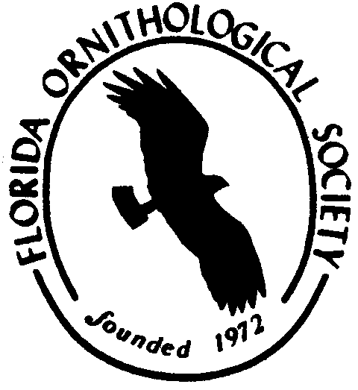
Florida Ornithological Society
Membership Form

Please use this form to join the Florida Ornithological Society or renew your membership. FOS membership is on a calendar year basis. Membership dues received from January through October are applied to the same calendar year, while dues received from November through December are applied to the following calendar year. Regardless of when a member joins, the member will receive a full year (4 issues) of the Florida Field Naturalist for the calendar year in which the member joined. Your membership is important because it assists the Society achieve its goals of advancing ornithology in Florida and supporting research and education about birds. A gift to the FOS will also help to achieve these goals. For more information about membership benefits and society activities, please visit our website: www.fosbirds.org. You may also renew or join using PayPal at the FOS website.

Name: Last First Phone

E-mail

New Member Renewal (if address has not changed, leave blank)

Street Address City State, Zip

Membership:
Student $15.00 ______
Individual $25.00 ______
Family $30.00 ______
Contributing $45.00 ______
Institution/Library $40.00 ______
Individual Life $400.00 ______
Family Life $500.00 ______

Gifts
General Fund $ __________
Endowment Fund $ __________
Cruickshank Award $ __________
Robertson Award $ __________
Friends of FFN $ __________
Student Fund $

Total
Membership Total $ _________
Gift Total $ _________
Overseas (add $5.00) $ _________
Total Enclosed: $ _________

Please make your check payable to: FLORIDA ORNITHOLOGICAL SOCIETY
Send to: Michelle Wilcox, 2576 Congaree Rd, Gadsden, SC 29052

