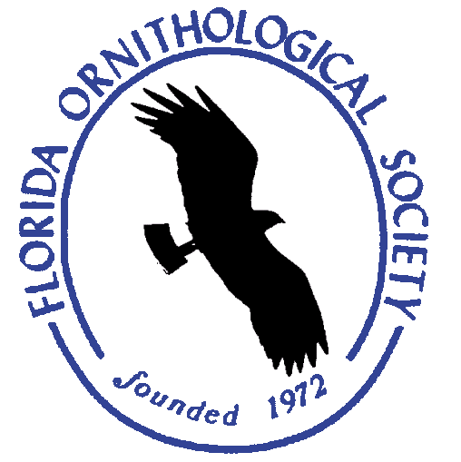
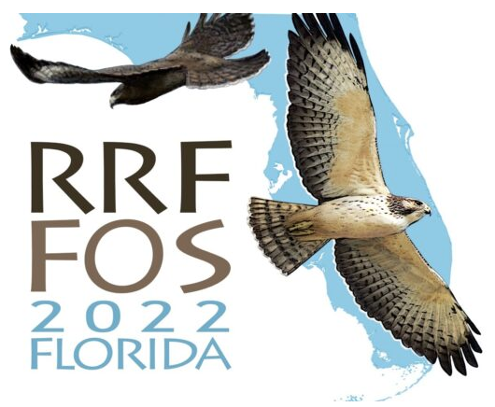
Florida Ornithological Society’s
50th Anniversary Celebration and Fall Meeting
and Raptor Research Foundation’s
Fall Meeting ~ October 4-9

Hosted by
Tropical Audubon Society

Embassy Suites by Hilton & Stranahan House, Ft. Lauderdale

Accommodations – Please make your own lodging arrangements
Embassy Suites by Hilton, 1100SE 17th St., Ft. Lauderdale
For the FOS portion of the Meeting – Please use the attached registration form
Schedule
Tuesday-Friday See Raptor Research Foundation to register, use the FOS registration https://raptorresearchfoundation.org/events/current-conference/
To attend the RRF portion - FOS/RRF members: before 9/8 - $230, before 10/9 - $285

Friday, October 7 Activities centered at the Embassy Suites, Ft. Lauderdale
7:30 a.m. and 2:00 p.m. Field trips, car pools leave from Embassy Suites or meet at the site
2:00 p.m. FOS Board of Directors’ Meeting
2:00-5:30 p.m. Registration
2:00-5:30 p.m. Field trips
6:00 p.m. Banquet with RRF

Saturday, October 8 Activities at the Stranahan House
7:30 a.m. Field trips, car pools leave from Embassy Suites or meet at the site
Noon Lunch, Cuban sandwiches by Padrino’s Cuban Restaurant, Stranahan House
1:00 p.m. FOS Business Meeting: Stranahan House
1:15-3 p.m. Student Scientific Presentations
3:00 p.m. Mid-afternoon Break, refreshments served
3:15-5:00 p.m. Scientific Presentations - Birds of South Florida
5:00-5:30 p.m. Bird Skin Quiz (provided by the Florida Museum of Natural History, Andy Kratter)
5:30 p.m. Flocking Reception
6:00 p.m. Welcome, Report on the Status of the BBA II, Jim Cox and Dr. Ann Hodgson
50 Years of the Florida Ornithological Society, Andy Huse, University of South Florida
Banquet: Padrino’s Cuban Restaurant, caterers
Keynote Lecture: Jim Kushlan, 75 years of the Everglades National Park
Announcements, Field Trip Reports
Sunday, October 9
7:30 a.m. Field trips, car pools leave from Embassy Suites or meet at the site

- - - - - - - - - - - - - - - - - - - - - - - - - - - - - - - - - - - - - - - - - - - - - -
Mail your Registration Form & Check made out to FOS to Mary Mack Gray, 1909 Sherwood Drive, Tallahassee, FL32303 or go on-line to fosbirds.org

Please send in your registration before September 30, 2022. After that, call or email to register.

Questions or late registration: Mary Mack Gray, graymarymack@gmail.com.

Name(s):

Address:

City: State: Zip code:

Email address:

FOS Meeting Registration @ $80/person

Student Registration @ $10/student

LATE FEE (after September 30) additional $10/person

Meals Friday Evening Banquet with Raptor Research Foundation
$40 X ______ people or pay on RRF registration page

Saturday, Lunch $20 X ______ people

Saturday Evening Banquet $40 X ______ people

Total Enclosed

